

Module Code: PUSL3134 | Module Name: Software Project Management
Coursework Title: Project report of computer hardware & accessories selling store
Deadline Date:10/27/2025 | Member of staff responsible for coursework:01
Programme: BSc (Hons) software Engineering
Please note that University Academic Regulations are available under Rules and Regulations on the University website www.plymouth.ac.uk/studenthandbook.
Group work: please list all names of all participants formally associated with this work and state whether the work was undertaken alone or as part of a team. Please note you may be required to identify individual responsibility for component parts.

Vithanage Bandara- 10818157
We confirm that we have read and understood the Plymouth University regulations relating to Assessment Offences and that we are aware of the possible penalties for any breach of these regulations. We confirm that this is the independent work of the group.

Signed on behalf of the group:
Individual assignment: I confirm that I have read and understood the Plymouth University regulations relating to Assessment Offences and that I am aware of the possible penalties for any breach of these regulations. I confirm that this is my own independent work.

Signed :
Use of translation software: failure to declare that translation software or a similar writing aid has been used will be treated as an assessment offence.
I *have used/not used translation software.
If used, please state name of software…………………………………………………………………
Overall mark % Assessors Initials Date
*Please delete as appropriateSci/ps/d:/students/cwkfrontcover/2013/14


PUSL3134
Software Project Management
2024/2025
Extended Referral Coursework

Term: Third Term
Submission Deadline: 10/27/2025
Coursework Type: Individual Assignment
Module Leader: Mr. Aruna Kooragamage
E-mail: akooragamage@gmail.com

Contents
1. Introduction 1
1.1 Purpose of the Document 1
1.2 Project Overview 1
1.3 Scope of the Project 2
1.4 Project Approval Process 2
1.5 Target Audience 3
1.6 Summary 3
2. Project Charter 4
2.1 Purpose and Objectives 4
2.2 Scope of the Project 4
2.3 Key Requirements and Acceptance Criteria 5
2.4 Exclusions 6
2.5 Stakeholders 6
2.6 Total Budget (LKR) 7
2.7 Milestone Dates 7
3. Project Solution Architecture 8
3.1 Introduction 8
3.2 Context Diagram 8
3.3 System Structure 9
3.4 System Behaviour 11
3.5 System Allocations 11
3.6 Communications Between Components 12
3.7 Entity–Relationship Model 12
3.8 Summary 14
4. Release Plan 15
4.1 Release Goals 15
4.2 Key Features for Release 15
4.3 Release Planning Process 17
4.4 Iterations and Dependencies 18
4.5 Sprint Monitoring and Tracking 18
4.6 Release Commitment 19
5. Kanban Chart 20
5.1 Purpose of the Kanban Chart 20
5.2 Overview of the Kanban System 20
5.3 Kanban Workflow Description 21
5.4 Benefits of the Kanban Approach 23
5.5 Kanban Chart Reference 24
6. Project Plan using XL (Gantt Chart) 25
6.1 Purpose of the Project Plan 25
6.2 Project Timeline Overview 25
6.3 Key Milestones 27
6.4 Dependencies and Task Flow 27
6.5 Monitoring and Control 28
6.6 Gantt Chart Reference 28
7. Preliminary Budget 29
7.1 Purpose of the Budget 29
7.2 Labour Costs 29
7.3 Infrastructure & Overheads 30
7.4 Payment Gateway Costs 31
7.5 Contingency and Risk Factors 31
7.6 Final Estimated Budget Summary 32
7.7 Assumptions 32
7.8 Risk and Budget Control 32
8. Conclusion 33
9. Appendices 35
Appendix 1: Figma Design (UI/UX Prototypes) 35
Appendix 2: Solution Architecture Diagram 36
Appendix 3: Enhanced Entity-Relationship (EER) Diagram 36
Appendix 4: Kanban Chart 37
Appendix 5: Gantt Chart 37
10. References 38

1. Introduction

1.1 Purpose of the Document

This document presents a comprehensive report on the design and development of VSKTech, an e-commerce web and mobile application focused on selling computer hardware and accessories. It outlines the project charter, solution architecture, release plan, Kanban chart, Gantt chart, and preliminary budget, offering a structured view of the planning, management, and execution phases.

The primary purpose of this document is to formally communicate the scope, objectives, key deliverables, milestones, and methodologies used in managing the VSKTech project. It is prepared to demonstrate how the project will be executed from initiation to closure, ensuring that all client and stakeholder requirements are met within the defined budget, scope, and timeline.

1.2 Project Overview

VSKTech is an innovative cross-platform e-commerce solution comprising two core components:

- VSKTech Web – A responsive web application enabling customers to browse and purchase computer hardware and accessories conveniently.

- VSKTech Mobile – A mobile application designed to provide an optimized, on-the-go shopping experience for smartphone users.

The system integrates smart features such as a price comparison engine, low-price filtering, and an AI-powered chatbot that supports users with product inquiries, troubleshooting, and order tracking. VSKTech aims to create a transparent and intelligent shopping experience, giving customers the confidence to make informed purchasing decisions with minimal effort.

1.3 Scope of the Project

The scope of VSKTech focuses on delivering a robust, scalable, and user-friendly e-commerce ecosystem. Key areas include:

- Product Listings & Management – A dynamic catalog of hardware and accessories from multiple brands.
- User-Friendly UI/UX – Simple, modern interfaces ensuring easy navigation and fast product search.
- Price Comparison Feature – Enables users to compare similar products across different brands.
- Low-Price Filtering – Displays the most affordable items in each category automatically.
- AI-Powered Chatbot – Provides 24/7 support for inquiries, recommendations, and order updates.
- Secure Payment Integration – Supports local and international payment gateways such as PayHere and PayPal.
- Order Tracking System – Keeps customers informed from purchase to delivery.

Through these features, VSKTech is positioned not as a traditional e-commerce store but as a next-generation, AI-driven retail solution that prioritizes transparency, affordability, and customer engagement.

1.4 Project Approval Process

An initial concept proposal for VSKTech was submitted to the course supervisor for evaluation and approval. Following feedback, the project’s scope, structure, and objectives were refined to ensure alignment with industry best practices and academic assessment standards. Key improvements included the addition of AI-driven support features, a modernized UI/UX, and a structured project management approach using Kanban and Gantt chart tracking.

1.5 Target Audience

The target audience for VSKTech includes the following user groups:

- Tech Enthusiasts – Individuals seeking the latest hardware and accessories.
- Gamers and Content Creators – Users needing high-performance components such as GPUs, CPUs, and peripherals.
- Small Businesses and IT Professionals – Organizations purchasing hardware in bulk for operations or client projects.

VSKTech caters to both casual and professional buyers, offering an intelligent, affordable, and reliable platform designed to enhance the overall online shopping experience.

1.6 Summary

In summary, VSKTech is a technologically advanced e-commerce platform that integrates AI-driven assistance, real-time price comparison, and secure online transactions into a seamless user experience. It bridges the gap between affordability and innovation, setting a new benchmark for how customers purchase computer hardware and accessories online.



2. Project Charter

2.1 Purpose and Objectives

The purpose of the VSKTech Project is to design and develop an integrated e-commerce web and mobile application for selling computer hardware and accessories. The project aims to create a scalable, intelligent, and user-friendly system that enhances the customer shopping experience while improving operational efficiency for the business.

Project Objectives

- Develop and deploy the VSKTech Web and VSKTech Mobile platforms with full e-commerce functionality.
- Implement price comparison and low-price filtering features to improve purchase decisions.
- Integrate an AI-powered chatbot for customer assistance, FAQs, and order tracking.
- Ensure secure and seamless payment integration via PayHere and PayPal.
- Build an Admin Dashboard for managing inventory, customers, and sales data.
- Complete the project within the allocated budget and timeline (Deadline: 25 October 2025).

2.2 Scope of the Project

The VSKTech system will deliver the following major components:

- Front-End Development:
Responsive UI/UX for both mobile and web platforms using Java (Android Studio) and modern web frameworks.

- Back-End Development:
A scalable server and database architecture using Firebase (Authentication, Firestore, and Cloud Storage).

- AI Chatbot Integration:
Intelligent chatbot to assist users with navigation, order updates, and product support.

- Payment Integration:
Secure transaction systems supporting multiple gateways (PayHere, PayPal).

- Order Management System:
Tracks and manages user orders from placement to delivery.

- Admin Dashboard:
Centralized tool for managing product listings, user accounts, and analytics.

2.3 Key Requirements and Acceptance Criteria

Requirement | Acceptance Criteria
User Registration & Login | Users can securely register, log in, and manage profiles using Firebase Authentication.
Product Listings | Users can browse, filter, and search for hardware items easily.
Price Comparison | Users can view and compare prices across different brands or models.
Low-Price Filtering | System automatically displays the lowest available options per category.
AI Chatbot | Chatbot accurately responds to queries and assists users with navigation and support.
Payment Gateway Integration | Users can securely complete transactions using PayHere or PayPal.
Order Tracking | Customers receive real-time updates on order status.
Mobile & Web Compatibility | Both applications perform efficiently on Android and desktop browsers.

2.4 Exclusions
The project does not include:

- Physical inventory or warehouse management (handled by third-party suppliers).
- Delivery or logistics tracking systems.
- Marketplace functionality for external sellers.
- Advanced AI features such as predictive analytics or machine learning recommendations (reserved for future upgrades).

2.5 Stakeholders

Stakeholder | Role & Responsibility
Project Manager | Oversees project planning, execution, and delivery (Vithanage Bandara).
Development Team | Handles software development, testing, and deployment.
UI/UX Designer | Designs web and mobile interfaces ensuring accessibility and usability.
Client / Business Owner | Approves requirements, budget, and deliverables.
End Users | Customers purchasing products via VSKTech.
Vendors / Suppliers | Provide computer hardware and accessories listed on the platform.

2.6 Total Budget (LKR)

Category | Estimated Cost (LKR)
Web Development | 1,200,000
Mobile App Development | 1,500,000
AI Chatbot Development | 800,000
UI/UX Design | 400,000
Testing & Debugging | 300,000
AWS Hosting & Cloud Services | 900,000
CloudFront CDN & SSL | 180,000
Domain & Licensing | 45,000
Payment Gateway Integration | 220,000
Marketing & Launch | 600,000
Contingency Fund (10%) | 640,000
Total Estimated Budget | LKR 6,785,000

2.7 Milestone Dates

Milestone | Expected Completion Date
Project Initiation & Planning | March 1, 2025
UI/UX Design Finalization | April 1, 2025
Front-End Development (Web & Mobile) | May 1, 2025
Back-End Integration & Database Setup | June 10, 2025
AI Chatbot Implementation | July 1, 2025
Payment Gateway Integration | July 25, 2025
System Testing & Debugging | August 15, 2025
Mobile App Deployment | September 1, 2025
Web App Deployment | September 20, 2025
Marketing & Pre-Launch | October 10, 2025
Final Project Delivery (Go Live) | October 25, 2025

3. Project Solution Architecture

3.1 Introduction

The VSKTech Solution Architecture defines the technical structure, system behavior, and data flow between components of the e-commerce ecosystem. It ensures that both the web and mobile applications operate efficiently, securely, and consistently within the same cloud-based environment.

This architecture follows a modular, scalable, and service-oriented design to ensure flexibility for future enhancements such as AI analytics and third-party integrations.

3.2 Context Diagram

The context diagram of VSKTech illustrates how the system interacts with external entities including customers, administrators, suppliers, and payment gateways.

External Components:

- Customers: Access the system via web browsers or mobile applications to browse, purchase, and track orders.
- Administrators: Manage product listings, orders, and users via the admin dashboard.
- Suppliers: Provide computer hardware and accessories added to the catalog.
- Payment Gateways: PayHere and PayPal handle secure financial transactions.
- Cloud Infrastructure: Firebase and AWS handle hosting, data storage, and authentication.

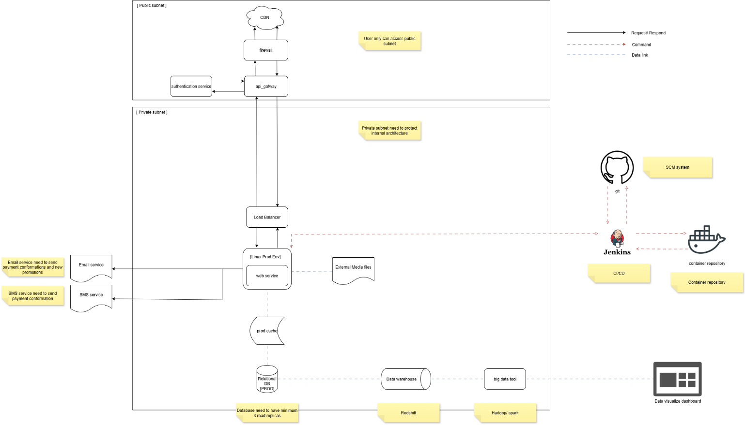

Figure 1: VSKTech System Architecture.

3.3 System Structure

The architecture is divided into four major layers, each responsible for specific functionalities:

1. Presentation Layer (Front-End)

- VSKTech Web: Built using ReactJS or Angular for responsive, dynamic interfaces.
- VSKTech Mobile: Developed in Android Studio using Java or Kotlin for Android devices.

- Provides product browsing, filtering, cart management, and order tracking.
- Ensures consistent UI/UX across both platforms.

2. Application Layer (Back-End)

- Developed using Node.js and Express or integrated Firebase Cloud Functions.
- Manages business logic including authentication, product management, and order processing.
- Handles requests from front-end and interacts with databases and APIs.

3. Database Layer

- Firebase Firestore: Stores structured data (user profiles, orders, and product details).
- Cloud Storage: Maintains product images, documents, and multimedia assets.
- MySQL (optional hybrid use): Used for structured analytics data if required for reports.

4. Integration Layer (External APIs & Services)

- PayHere / PayPal APIs: Process secure online payments.
- AI Chatbot API (Dialogflow / TensorFlow): Provides automated assistance.
- Notification Services (Firebase Cloud Messaging): Sends real-time updates to users.

3.4 System Behaviour

The VSKTech system responds dynamically to internal and external actions in the following manner:

User Action | System Response / Behaviour
User logs in or registers | Firebase Authentication validates and stores credentials.
User searches or filters products | System fetches relevant data from Firestore in real time.
User compares prices | The app queries multiple brand listings and displays the lowest price.
User adds item to cart and proceeds to payment | The checkout process initializes a secure payment session with PayHere or PayPal.
Order is placed | Order details are recorded in the database, and the user receives an instant confirmation.
Chatbot interaction | AI chatbot retrieves relevant answers or data via Dialogflow and displays them in-app.
Admin updates product data | Admin dashboard updates the Firestore database and reflects changes instantly.

This behavior ensures a seamless and responsive shopping experience for end-users while maintaining system stability and data integrity.

3.5 System Allocations

Component | Allocated Resources | Purpose
Front-End Hosting | Firebase Hosting (Web) | Handles web app deployment and delivery.
Back-End Services | Firebase Cloud Functions | Manages authentication, order logic, and data handling.
Database | Firestore & Cloud Storage | Stores structured and unstructured data securely.
Bandwidth | 10,000 concurrent users | Ensures smooth load handling during high traffic.
Security | SSL + Firebase Rules | Encrypts data transmission and access control.
AI Chatbot | Google Dialogflow / TensorFlow | Provides NLP-based user support.

3.6 Communications Between Components

VSKTech uses standard and secure communication protocols to ensure smooth and reliable data exchange between system modules.

Protocol / Method | Purpose
RESTful APIs | Handles communication between front-end and back-end services.
WebSocket | Enables real-time order updates and chatbot interactions.
HTTPS | Ensures secure transactions and data transmission.
Firebase Messaging APIs | Sends order notifications and updates to users.
Payment Gateway APIs | Securely processes payments through PayHere and PayPal.

3.7 Entity–Relationship Model

The EER Diagram provides a detailed representation of how entities interact within the database.
Key entities include User, Product, Order, Payment, ChatbotLog, and Feedback.

Entity Relationships:

- A User can place multiple Orders.
- Each Order contains one or more Products.
- Payments are linked to Orders.
- Feedback is associated with both User and Product entities.
- ChatbotLog stores customer support interactions.

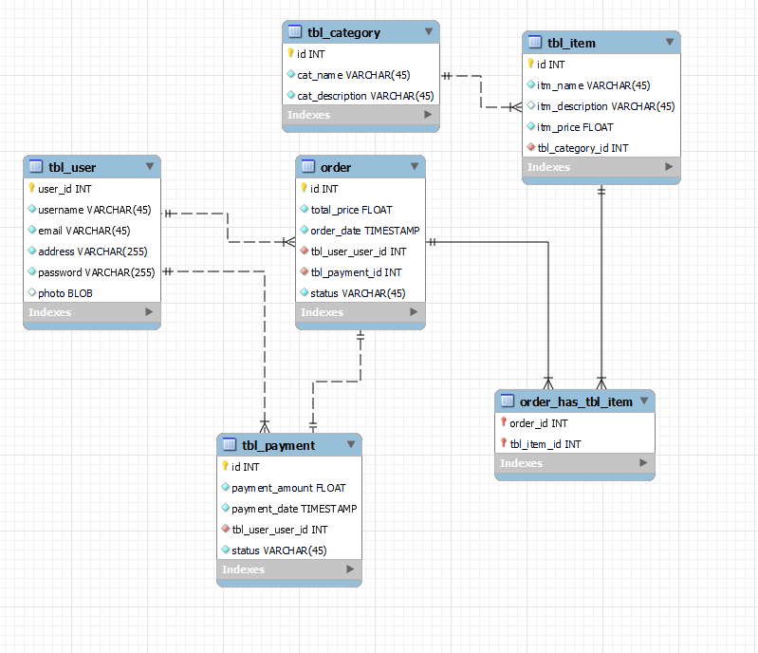

Figure 2: VSKTech EER Diagram.

3.8 Summary

The VSKTech Solution Architecture provides a solid, future-proof technical foundation for the system. It ensures modularity, scalability, and maintainability while maintaining security and high performance. The use of Firebase, AWS, and RESTful APIs enables reliable communication between components, while the AI chatbot integration enhances user engagement and support.

4. Release Plan

4.1 Release Goals

The release plan for VSKTech aims to deliver a high-quality, fully functional e-commerce web and mobile platform for selling computer hardware and accessories. The plan ensures that the system is developed in incremental phases, aligning with Agile project management practices for flexibility, transparency, and stakeholder feedback.

The key goals of the release are:

- To design, develop, and deploy the web and mobile platforms within the approved timeline.
- To ensure feature completeness with seamless payment integration and AI chatbot support.
- To guarantee stability, scalability, and security before public launch.
- To align all sprint deliverables with milestones, as outlined in the Kanban and Gantt charts.

4.2 Key Features for Release

The following core features are planned for delivery in the release cycle:

- User Authentication & Profiles – Secure registration, login, and profile management.
- Product Listings & Categorization – Comprehensive catalog of hardware and accessories.
- Price Comparison & Filtering – Smart tools for finding the best-value products.
- Shopping Cart & Checkout – User-friendly cart system with integrated payment gateways.
- Payment Gateway Integration – PayHere (local) and PayPal (international) support.
- AI Chatbot Support – Real-time assistance for inquiries and order tracking.
- Order Management & Notifications – Automated status updates and delivery tracking.
- Admin Dashboard – For managing catalog, inventory, and customer interactions.
- Web and Mobile Deployment – Publishing and go-live on both web and app stores.

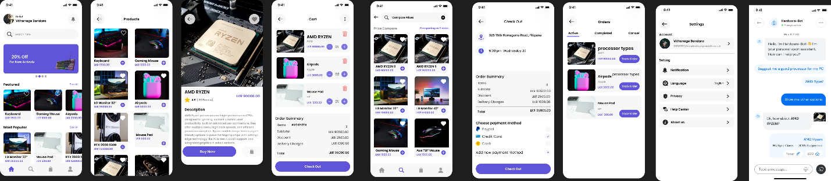
Figure 3: VSKTech Figma Mobile Design.

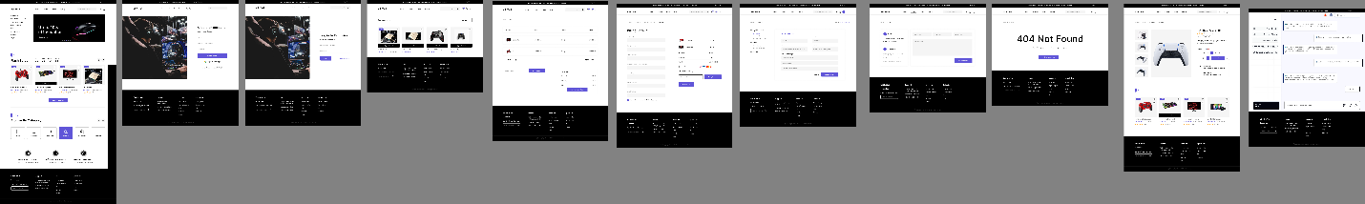

Figure 4: VSKTech Figma Web Design.

4.3 Release Planning Process

The release follows an iterative Agile model, broken down into five key phases that align directly with the Kanban workflow and Gantt chart. Each phase corresponds to tasks with specific responsibilities and completion targets.

Phase / Sprint | Duration | Major Deliverables | Responsible Members
Sprint 1 – Project Planning (1–21 March 2025) | 3 weeks | Project initiation, scope definition, user stories, EER/class diagrams, and wireframes finalized. | Sahan, Kasun, Kavinda
Sprint 2 – UI/UX Design (22 March – 10 April 2025) | 3 weeks | UI/UX mockups for web and mobile apps designed and approved using Figma. | Kasun, Kavinda
Sprint 3 – Front-End Development (1 May – 15 May 2025) | 2 weeks | Implementation of responsive front-end for both web and mobile apps. | Kasun
Sprint 4 – Back-End Integration (16 May – 30 June 2025) | 6 weeks | Back-end setup, database integration, and API communication. | Kavinda
Sprint 5 – Chatbot & Payment Integration (1 July – 25 July 2025) | 3.5 weeks | Implementation of AI chatbot and PayHere/PayPal payment gateway integration. | Sahan, Kavinda
Sprint 6 – Testing & Quality Assurance (26 July – 20 September 2025) | 8 weeks | Functional, unit, and stress testing; QA reporting and debugging. | Mila
Sprint 7 – Deployment & Handover (21 September – 25 October 2025) | 5 weeks | Production deployment, training materials, documentation, and final handover. | Entire Team

4.4 Iterations and Dependencies

- High-priority features (authentication, catalog, and checkout) are developed first to enable early testing.
- Medium-priority features (chatbot, admin dashboard) are introduced mid-cycle.
- Dependencies: Payment gateway APIs, AWS hosting, and chatbot API integrations are key dependencies.
- Critical risks (chatbot accuracy, load performance) are scheduled early enough for rework and optimization.

4.5 Sprint Monitoring and Tracking

Progress across all sprints will be tracked using:

- Kanban Chart (Appendix 4) – To visualize task status and team responsibilities.
- Gantt Chart (Appendix 5) – To monitor dependencies, durations, and overall progress.
- Weekly Stand-ups & Reviews – To evaluate sprint goals and adjust timelines if needed.

All progress updates will be documented in the project tracking sheet and reviewed by the project manager weekly.

4.6 Release Commitment

The project team commits to the completion of all deliverables within the defined timeframe of March to October 2025, with the final go-live scheduled for October 25, 2025.

The development approach emphasizes incremental delivery, allowing continuous integration and quality assurance at every stage.

5. Kanban Chart

5.1 Purpose of the Kanban Chart

The Kanban chart serves as a visual project management tool that tracks tasks, responsibilities, and progress throughout the VSKTech e-commerce application development lifecycle. It provides a real-time overview of the project’s workflow from initial planning to deployment helping the project team maintain transparency, focus, and accountability.

By implementing the Kanban approach, the development process remains Agile, allowing tasks to be continuously monitored and updated as they progress through various stages such as To Do, In Progress, Testing, and Done.

5.2 Overview of the Kanban System

The Kanban board used for the VSKTech project is structured to reflect the five main project phases defined in the Release Plan and Gantt Chart:

- Project Planning Stage
- Designing Stage
- Development Stage
- Testing Stage
- Deployment and Handover Stage

Each task within these stages is associated with a start and end date, assigned team member, and completion percentage, ensuring measurable accountability and milestone tracking.

The Kanban system was created in Microsoft Excel, which allows easy visualization of project progress, task priority, and current completion status. The chart is regularly updated by the project manager to reflect progress and identify potential bottlenecks.

5.3 Kanban Workflow Description

A. Project Planning Stage (1 July – 21 July 2025)

This stage covers foundational activities essential for defining the project’s direction and deliverables.

Key Tasks:

- Define project scope and objectives
- Research market trends and customer requirements
- Develop user stories and requirements backlog
- Create system diagrams (EER, Class diagrams)
- Prepare wireframes and confirm project deliverables

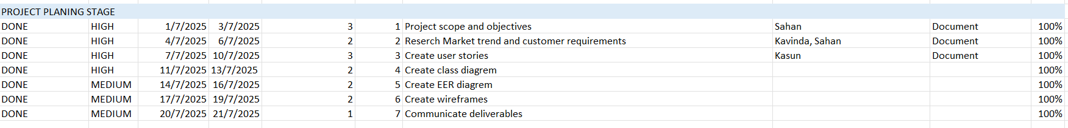

Status: All planning tasks completed by 21 July 2025.

B. Designing Stage (22 July – 1 August 2025)

This phase involves finalizing the visual layout and design specifications of the VSKTech web and mobile applications.

Key Tasks:

- Design UI/UX mockups for web and mobile interfaces using Figma
- Finalize color schemes, typography, and style guides
- Review and approve design prototypes

Deliverables: Approved Figma design files for both platforms.
Status: Completed successfully and approved by the client.
C. Project Development Stage (2 August – 3 September 2025)

The development stage transforms the approved designs into functional software.

Key Tasks:

- Configure development environments (Dev, QA, Test)
- Develop front-end for web and mobile applications
- Implement back-end architecture, APIs, and database integration
- Integrate payment gateways (PayHere, PayPal)
- Implement cart and checkout functionality

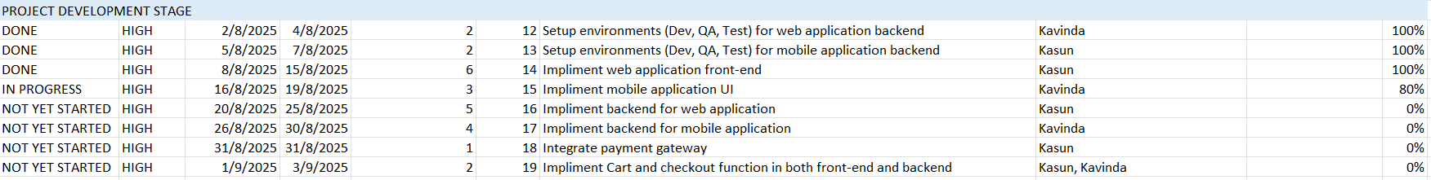

Status: In progress — front-end completed, mobile UI 80% done, backend integration scheduled for completion by early September 2025.

D. Project Testing Stage (3 September – 26 September 2025)

In this stage, comprehensive testing ensures the reliability, performance, and functionality of all modules.

Key Tasks:

- Deploy builds to QA/Test environments
- Conduct unit, integration, and stress/load testing
- Execute functional requirement and user acceptance testing (UAT)

Deliverables: QA test reports, UAT approval, and bug resolution summary.
Status: Scheduled; testing to begin once back-end integration is completed.
E. Deployment and Handover Stage (27 September – 9 October 2025)

This final stage focuses on system release, documentation, and knowledge transfer.

Key Tasks:

- Deploy backend and frontend to production environments
- Upload mobile application to Google Play and App Store
- Conduct production testing and finalize documentation
- Prepare training materials and post-launch monitoring plan

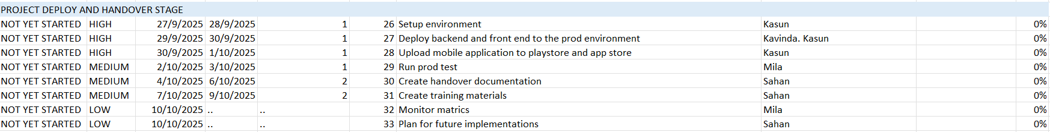

Deliverables: Production-ready web and mobile apps, training documents, and handover package.
Status: Planned completion by 9 October 2025, followed by continuous monitoring until October 25, 2025 (Go Live).

5.4 Benefits of the Kanban Approach

Using the Kanban method for this project provides the following advantages:

- Real-time progress visualization — team members can see task movement instantly.
- Improved workflow efficiency — tasks flow smoothly between planning, design, development, testing, and deployment.
- Reduced project bottlenecks — early detection of issues through continuous status tracking.
- Enhanced collaboration — clear task ownership among developers, designers, testers, and the project manager.
- Client transparency — regular updates to stakeholders through visible progress charts.

5.5 Kanban Chart Reference

The detailed Kanban chart for the VSKTech project is included in Appendix 4 and provided as a separate Excel file (Kanban chart.xlsx).
It visually represents all 33 project tasks, their durations, responsible members, and completion percentages, directly supporting the milestones listed in Section 2.7 and the Release Plan in Chapter 4.

Kanban Chart URL - Kanbanchart.xlsx

6. Project Plan using XL (Gantt Chart)

6.1 Purpose of the Project Plan

The Gantt Chart serves as the central scheduling and tracking tool for the VSKTech E-commerce Application project.
It visualizes each phase of the project timeline from initiation to delivery, while showing task dependencies, start and end dates, durations, and milestones.

The Gantt Chart ensures that all project members understand the workflow, deadlines, and interdependencies, supporting accurate progress tracking and effective project control.
It is developed using Microsoft Excel, which provides flexibility for updates and integration with other project documentation such as the Kanban Chart and Release Plan.

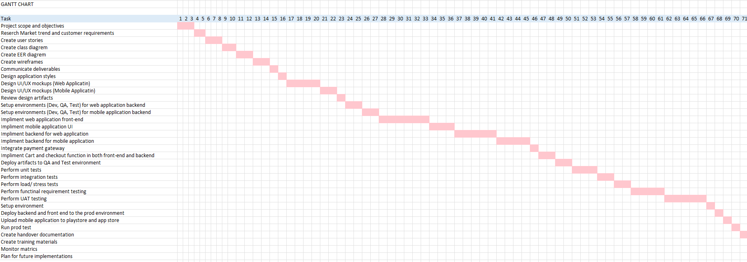

Figure 2: VSKTech Gantt Chart.

6.2 Project Timeline Overview

The project is structured across seven main phases that follow a logical sequence of planning, design, development, testing, and deployment.
The overall timeline spans from March 1, 2025 to October 25, 2025, matching the key milestone dates listed in Section 2.7 of the Project Charter.

Phase | Duration | Description | Key Deliverables
1. Project Initiation & Planning | March 1 – March 21, 2025 | Define objectives, scope, user stories, and system diagrams. | Project Charter, EER/Class Diagrams, Wireframes
2. UI/UX Design | March 22 – April 10, 2025 | Create visual mockups for web and mobile apps, confirm layouts. | Figma Design Files
3. Front-End Development | May 1 – May 15, 2025 | Develop responsive interfaces for both web and mobile. | Functional UI Components
4. Back-End Integration & Database Setup | May 16 – June 30, 2025 | Develop server logic, database schema, and APIs. | Connected Backend Systems
5. AI Chatbot & Payment Integration | July 1 – July 25, 2025 | Implement chatbot functionality and integrate PayHere/PayPal. | AI Chatbot Module, Payment System
6. Testing & Quality Assurance | July 26 – September 20, 2025 | Conduct testing (unit, integration, load, UAT). | QA Reports, Bug Fixes, UAT Approval
7. Deployment & Handover | September 21 – October 25, 2025 | Deploy applications, finalize documentation, and training. | Production Systems, Training Manuals, Handover Report

6.3 Key Milestones

The following are the major milestones derived from the Gantt Chart and aligned with the project plan:

Milestone | Expected Completion Date
Project Initiation & Planning Completed | March 21, 2025
UI/UX Design Approved | April 10, 2025
Front-End Development Completed | May 15, 2025
Back-End Integration Completed | June 30, 2025
AI Chatbot & Payment Gateway Integrated | July 25, 2025
Full System Testing Completed | September 20, 2025
Deployment and Handover Completed | October 25, 2025

These milestones are synchronized with the Kanban Chart’s task schedule, ensuring consistency across all project tracking documents.

6.4 Dependencies and Task Flow

- Design depends on planning: The UI/UX design starts only after the completion of user stories and wireframes.
- Development depends on design: Front-end and back-end tasks are initiated after the design approval.
- Testing depends on development: Unit and system testing begin only once the core modules are implemented.
- Deployment depends on testing: The final release is performed only after QA and UAT sign-offs.

This structured dependency ensures that no phase overlaps unnecessarily and that quality assurance is maintained throughout the project lifecycle.

6.5 Monitoring and Control

Project progress will be tracked weekly using three tools:

- Gantt Chart (Excel): To measure actual progress against the planned schedule.
- Kanban Board: To track individual task status and team workload.
- Progress Reports: Weekly updates to stakeholders summarizing achievements and delays.

Any deviation from the planned schedule will be immediately reviewed in coordination meetings, and corrective measures (like workload balancing or additional resources) will be applied as required.

6.6 Gantt Chart Reference

The full Gantt Chart for the VSKTech project is attached as “Gantt Chart.xlsx” in the appendices.
It visually represents the complete timeline of activities, durations, dependencies, and milestones, ensuring alignment with:

- Project Charter (Section 2.7 Milestones)
- Release Plan (Chapter 4)
- Kanban Chart (Chapter 5)

This comprehensive synchronization ensures full traceability and a professional, industry-standard project documentation structure.

Gantt chart URL - Gantt chart.xlsx

7. Preliminary Budget

7.1 Purpose of the Budget

The Preliminary Budget provides an estimated financial outline for the VSKTech E-commerce Web and Mobile Application Project.
It highlights the projected costs associated with labour, infrastructure, licenses, marketing, and other essential overheads.
The goal of this budget is to ensure that the project remains financially feasible while meeting all technical, functional, and quality requirements.

The estimates are based on current industry averages in Sri Lanka for software professionals and infrastructure costs.
A 10% contingency fund is also included to mitigate unforeseen risks or fluctuations in expenses during the project lifecycle.

7.2 Labour Costs

Labour is the most significant cost component due to the specialized skills required for full-stack development, mobile integration, and AI implementation.
Each cost is based on estimated person-months of effort multiplied by the average monthly rate for each role.

Role | Effort (Person-Months) | Rate (LKR/Month) | Estimated Cost (LKR)
Web Developer | 3 | 400,000 | 1,200,000
Mobile Developer | 3.5 | 430,000 | 1,505,000
AI/Chatbot Specialist | 2 | 400,000 | 800,000
UI/UX Designer | 1 | 400,000 | 400,000
QA Engineer (Testing) | 1 | 300,000 | 300,000
Project Manager | 1.5 | 350,000 | 525,000
Total Labour Cost | – | – | 4,730,000

Justification:

- Rates are aligned with mid-level developer salaries in Sri Lanka (2025 market).
- Duration and effort are proportionate to the 8-month project timeline (March–October).
- The distribution ensures adequate resources for both web and mobile platform development.

7.3 Infrastructure & Overheads

These costs include all tools, services, and hosting environments required to develop, test, and deploy the VSKTech platform.

Item | Estimated Cost (LKR)
AWS Hosting (EC2, RDS, S3) | 900,000
CloudFront CDN | 150,000
Domain Registration | 15,000
SSL Certificate | 30,000
Software Licenses (Figma, Android Studio, Dev Tools) | 200,000
Digital Marketing Campaign (SEO, Ads, Promotions) | 400,000
Product Launch Campaign (Social Media & PR) | 200,000
Total Infrastructure & Overheads | 1,895,000

Justification:

- AWS costs cover scalable cloud hosting for web and mobile API deployment.
- Marketing allocation ensures visibility and awareness during pre- and post-launch phases.
- Design and development licenses reflect typical one-year subscriptions for professional tools.

7.4 Payment Gateway Costs

Integration of secure payment gateways is critical for enabling both local and international transactions.

Integration Type | Estimated Cost (LKR)
PayHere (Local Gateway) | 100,000
PayPal (International Gateway) | 120,000
Total Payment Integration Cost | 220,000

Justification:
These costs cover developer integration fees, testing environments, and configuration of transaction APIs, ensuring compliance with financial security standards.

7.5 Contingency and Risk Factors

A 10% contingency fund is included to handle potential risks or cost overruns such as:

- Delays during development or testing phases.
- Additional client requests leading to scope expansion.
- Fluctuations in cloud infrastructure or API costs.
- Unforeseen technical issues during integration or deployment.

Contingency Allocation (10%) - 650,000 LKR

This fund acts as a financial buffer to maintain project stability under unexpected conditions.

7.6 Final Estimated Budget Summary

Category | Total (LKR)
Labour | 4,730,000
Infrastructure & Overheads | 1,895,000
Payment Gateways | 220,000
Contingency Fund (10%) | 650,000
Final Estimated Budget | 7,495,000 LKR

7.7 Assumptions

- Cloud hosting estimates are based on moderate traffic (approximately 10,000 monthly users at launch).
- Labour rates reflect average local salaries for developers and IT professionals in Sri Lanka.
- Marketing expenses assume a three-month promotional window before and after launch.
- Physical logistics (delivery, warehousing) are excluded, as they are outsourced to suppliers.
- All costs are calculated in Sri Lankan Rupees (LKR) and may vary slightly based on exchange rates or market conditions.

7.8 Risk and Budget Control

To ensure cost control, the project manager will:

- Review budget utilization at each sprint milestone.
- Conduct monthly financial reviews with stakeholders.
- Approve any additional costs through a formal change request process.
- Maintain expenditure transparency via the project accounting sheet.

This structured financial management approach minimizes the risk of overruns and ensures project sustainability within the allocated budget.

8. Conclusion

The VSKTech E-commerce Project has been strategically structured and managed to deliver a modern, scalable, and user-friendly online platform for purchasing computer hardware and accessories.
This report comprehensively documented each stage of the project lifecycle from initial planning and architecture design to release planning, task management, and financial estimation ensuring a transparent and well-coordinated project management approach.

The project began with defining clear objectives and scope, establishing a solid foundation through detailed project planning and requirement gathering.
The Solution Architecture was then designed to ensure modularity, security, and scalability, allowing seamless integration of front-end, back-end, and AI-driven components.
The Release Plan, Kanban Chart, and Gantt Chart collectively provided a synchronized roadmap that guides the entire team in maintaining progress, quality, and alignment with deadlines.

Financial planning was conducted through a comprehensive Preliminary Budget, outlining estimated costs for labour, infrastructure, and overheads, supported by a contingency fund for risk management.
This ensures the project remains within feasible limits while meeting all quality and functionality expectations.

As of the current stage:

- The planning and design phases have been completed successfully.
- Front-end development for both web and mobile platforms is progressing as scheduled.
- AI chatbot integration and payment gateway setup are the upcoming key deliverables.
- Testing, deployment, and launch activities are planned in accordance with the final milestone date of October 25, 2025.

The VSKTech project demonstrates the effective application of software project management principles including Agile planning, risk mitigation, and cost control ensuring that all objectives are delivered efficiently and on time.

Next Steps

- Complete remaining back-end development and integration tasks.
- Conduct comprehensive testing (unit, integration, and UAT) to ensure reliability.
- Deploy applications to production and mobile app stores.
- Execute digital marketing and launch campaigns.
- Perform post-launch monitoring, gather user feedback, and plan for iterative updates.

Through this structured approach, VSKTech is positioned to achieve its primary goal: delivering a robust and intelligent e-commerce solution that enhances customer experience, supports business growth, and sets a strong benchmark for future digital retail innovations.

9. Appendices

The appendices provide detailed supporting information, diagrams, and design resources that complement the main body of this report.
These materials include design prototypes, charts, and diagrams that support the planning, architecture, and visualization of the VSKTech E-commerce Web and Mobile Application Project.
Each appendix is referenced in the main document where appropriate to ensure clear traceability.

Appendix 1: Figma Design (UI/UX Prototypes)

Purpose:
This appendix contains the finalized user interface (UI) and user experience (UX) designs for both the VSKTech Web and VSKTech Mobile applications.
These designs represent the visual structure, layout, and navigation flow approved during the design phase.

Links:

- Mobile UI Prototype: Figma Mobile Design
- Web UI Prototype: Figma Web Design
Projects:

- Mobile : Figma Project Mobile.fig
- Web: Figma Project Web.fig
Summary:
The designs emphasize user-friendliness, responsive layouts, and consistent visual elements across devices. Both interfaces were created using Figma, ensuring scalability and modern design consistency aligned with e-commerce best practices.

Appendix 2: Solution Architecture Diagram

Purpose:
This diagram illustrates the overall structure of the VSKTech system, showing how different components (front-end, back-end, databases, and third-party services) interact.
It provides a visual summary of the architectural layers discussed in Chapter 3 – Project Solution Architecture.

Contents:

- System context and interaction flow
- Component relationships (front-end, back-end, database)
- External API integrations (chatbot, payment gateways, cloud hosting)

File: solution architecture sahan.png
(solution architecture.drawio)

Summary:
The architecture ensures modular design, scalability, and security across web and mobile platforms using Node.js, MySQL, MongoDB, and AWS infrastructure.

Appendix 3: Enhanced Entity-Relationship (EER) Diagram

Purpose:
This appendix includes the EER Diagram used during database modeling.
It demonstrates relationships between entities such as Users, Products, Orders, Payments, and Feedback, supporting both the functional and non-functional requirements of the application.

File: EER.PNG
(EER.mwb)

Summary:
The EER model defines key constraints, primary and foreign key relationships, and ensures data normalization, which supports efficient data retrieval and system scalability.

Appendix 4: Kanban Chart

Purpose:
This appendix includes the detailed Kanban chart used to manage project progress and task distribution across the project timeline.
It outlines task priorities, durations, start and end dates, responsible members, and completion percentages.

File: Kanban chart.xlsx
URL: Kanbanchart.xlsx

Summary:
The chart reflects the Agile workflow used in Chapter 5, covering all project stages; planning, design, development, testing, and deployment. From July 1 to October 9, 2025.

Appendix 5: Gantt Chart

Purpose:
This appendix includes the full Gantt chart used to visualize the project schedule and milestones.
It demonstrates task dependencies, durations, and alignment with the overall project timeline (March–October 2025).

File: Gantt chart.xlsx
URL: Gantt chart.xlsx

Summary:
The Gantt chart supports time management, progress tracking, and synchronization with the Release Plan and Kanban board, ensuring full consistency across all project documentation.

10. References

AltexSoft. (n.d.). What is Solution Architecture: Process, Solution Architect. [online] Available at: https://www.altexsoft.com/blog/solution-architecture/
[Accessed 15 Oct. 2025].

Amazon Web Services (2019). Pricing. [online] Amazon Web Services, Inc. Available at: https://aws.amazon.com/pricing/
[Accessed 15 Oct. 2025].

Amazon (2019). AWS Documentation. [online] Amazon.com. Available at: https://docs.aws.amazon.com/
[Accessed 15 Oct. 2025].

Atlassian. (2024). What is a Kanban Board? [online] Atlassian Agile Coach. Available at: https://www.atlassian.com/agile/kanban/boards
[Accessed 10 Oct. 2025].

Gillis, A. (2022). What is a Project Charter? Definition and Examples. [online] SearchCIO. Available at: https://www.techtarget.com/searchcio/definition/project-charter
[Accessed 8 Oct. 2025].

International Scrum Institute (2011). Scrum Release Planning - International Scrum Institute. [online] International Scrum Institute™. Available at: https://www.scrum-institute.org/Release_Planning.php
[Accessed 12 Oct. 2025].

MacNeil, C. (2024). How to Create (And Stick With) a Project Budget. [online] Asana. Available at: https://asana.com/resources/project-budget
[Accessed 9 Oct. 2025].

Martins, J. (2024). What is Project Planning? (Plus, 7 Steps to Write a Successful Project Plan). [online] Asana. Available at: https://asana.com/resources/project-management-plan
[Accessed 10 Oct. 2025].

PMI (2023). A Guide to the Project Management Body of Knowledge (PMBOK® Guide) – 7th Edition. Project Management Institute. Pennsylvania, USA.

Rehkopf, M. (2024). What is a Kanban Board? [online] Atlassian. Available at: https://www.atlassian.com/agile/kanban/boards
[Accessed 14 Oct. 2025].

